**Nested if**

Each of the above statements can be replaces by if..else statement using the same rules. For instance the first statement in the true branch can be replaced by another if structure as follows:

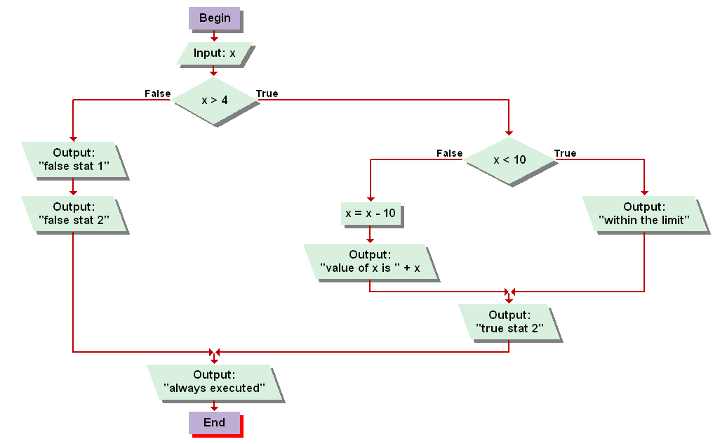

If we enter value 6 to x: the first condition (x > 4) is true and the program then will follow the true branch. It will meet the second condition (x < 10) which is also true, so it will follow the true branch to print “within the limit”, then print “true stat 2” and the last output is “always executed”.

If we enter value 16 to x: the first condition (x > 4) is true and the program then will follow the true branch. It will meet the second condition (x < 10) which is false, so it will follow the false branch to subtract 10 from x (x = 16 – 10 = 6) and print “value of x is 6”, then print “true stat 2” and the last output is “always executed”

If we enter value 2 to x: the first condition (x > 4) if false and therefore, the flow will go through the false branch to print “false stat 1” followed by “false stat 2”, and the last output is “always executed”

Exercise: convert the above flowchart into a C# code.

Solution:

System.out.println ("Enter a value: ");

int x = scan.nextInt ();

if (x > 4)

{

if (x < 10)

System.out.println ("within the limit");

else

{

x = x - 10;

System.out.println ("value of x is " + x);

}

}

else

{

System.out.println ("false stat 1");

System.out.println ("false stat 2");

}

System.out.println ("last statement");

Note: for the following statement

System.out.println ("value of x is " + x);

If we concatinate an integer to a string (as above), the string will be converted automatically to string. To prove this, try the following:

int x = 5;

int y = 3;

System.out.println ("x + y= " + x + y);

But this code will print: x + y= 53 (not 8) because x is concatinated to the string then conactinated with y. To get the correct answer x and y must be added first before we concatinated to the string as follows:

System.out.println ("x + y= " + (x + y));

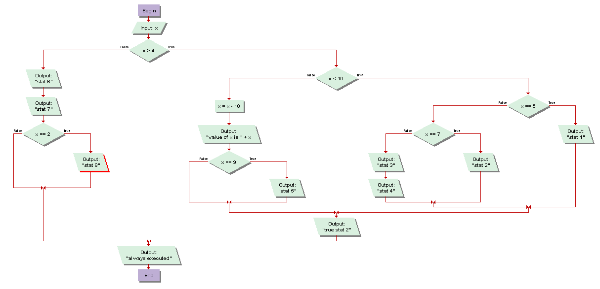Another complicated